**Experiment: 1**

**Aim:** Write a program to find sum of 1! + 2! + 3! + 4! + 5! Up to n terms

**Software:** Dev C++

**Code:**

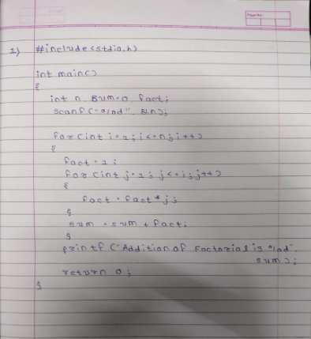

**Output:**

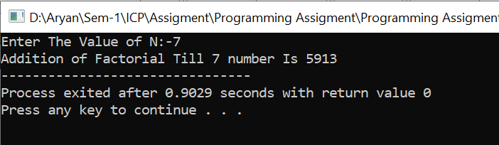

**Experiment: 2**

**Aim:** Print pattern like follow.

**Software:** Dev C++

**Code:**

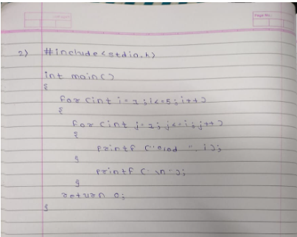

**Output:**

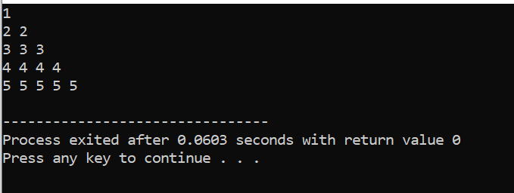

**Experiment: 3**

**Aim:**  Print pattern like follow.

**Software:** Dev C++

**Code:-**

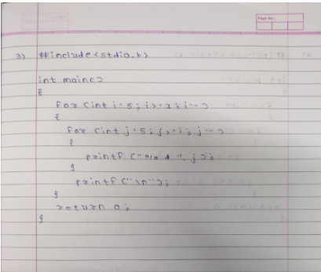

**Output:**

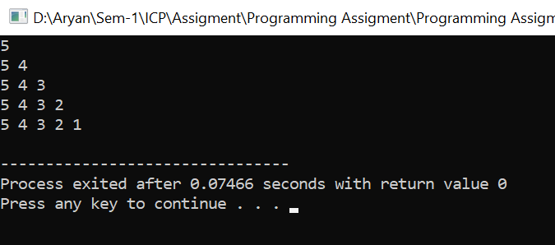

**Experiment: 4**

**Aim:**  Print pattern like follow.

**Software:** Dev C++

**Code:-**

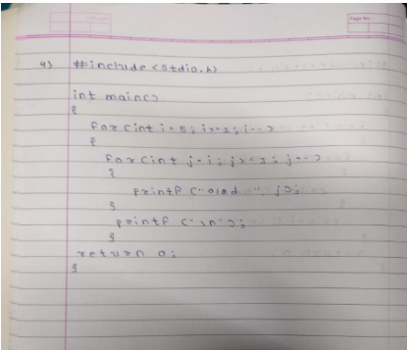

**Output:-**

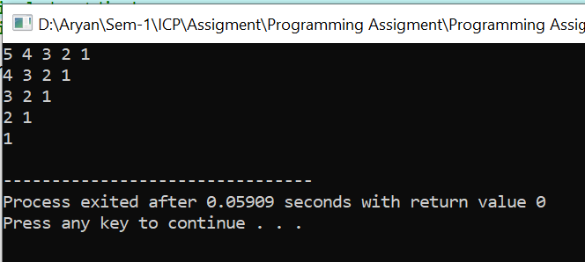

**Experiment: 5**

**Aim:-**  Write a program that perform the following output for n rows

**Software:-** Dev C++

**Code:-**

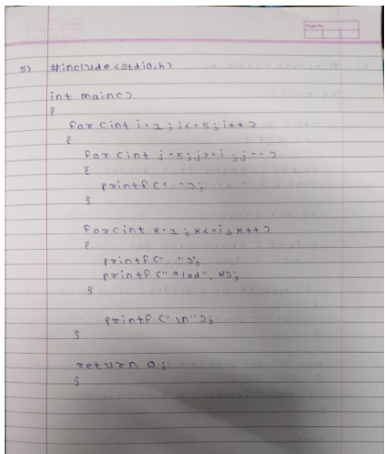

**Output:-**

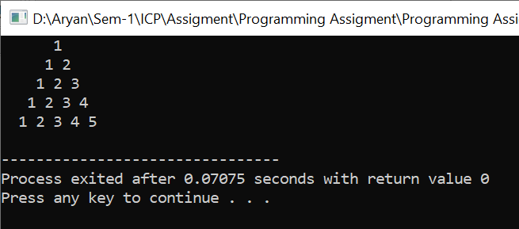

**Experiment: 6**

**Aim :-**  A company has introduced a policy of recruiting employees based on their sex and  
The policy is as follows:  
• For a female category the eligibility criterion is that the age of a person should be  
more than 24.  
• For a male category the age of a person should be more than 28.  
Write a program to find out whether a person can be employed if the age and sex of  
the person is entered through the keyboard.

**Software:-** Dev C++

**Code:-**

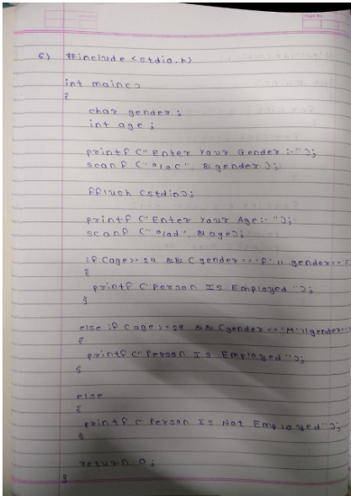

**Output:-**

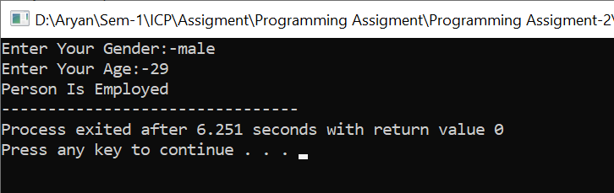

**Experiment: 7**

**Aim:-**  Write a program to check whether a number is an Armstrong number or not.  
(Armstrong number: the addition of the cube of the digit of a number = the number  
For example 153, 13 + 53 + 33 =153.)

**Software:-** Dev C++

**Code:-**

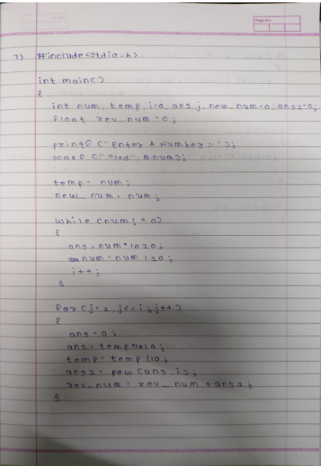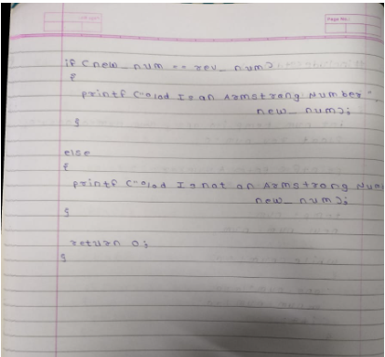

**Output:-**

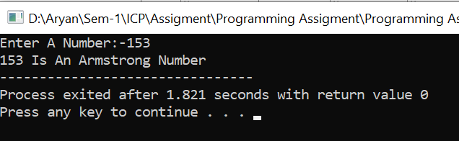

**Experiment: 8**

1. **Aim:-**  Write a program to count the number of even numbers in a range provided by the  
   user

**Software:-** Dev C++

**Code:-**

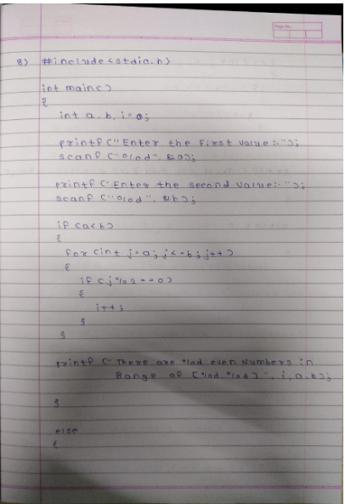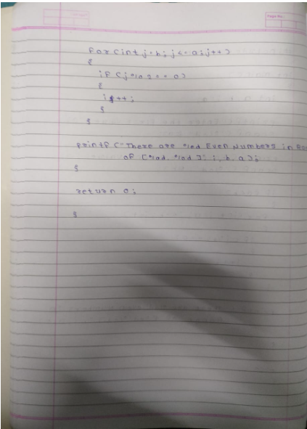

**Output:-**

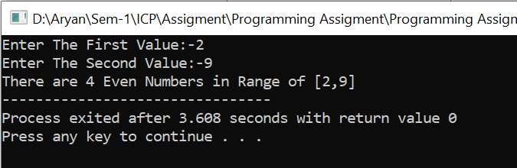

**Experiment: 9**

**Aim:-**  Calculate the commission for a sales representative as per the sales amount:  
if sales <= Rs 500, commission is 5%.  
• if sales > 500 and <= 5000, commission is Rs 35 plus 10% above Rs 500.  
• if sales > 2000 and < = 5000, commission is Rs 185 plus 12% above Rs 2000.  
• if sales > 5000, commission is 12.5%

**Software:-** Dev C++

**Code:-**

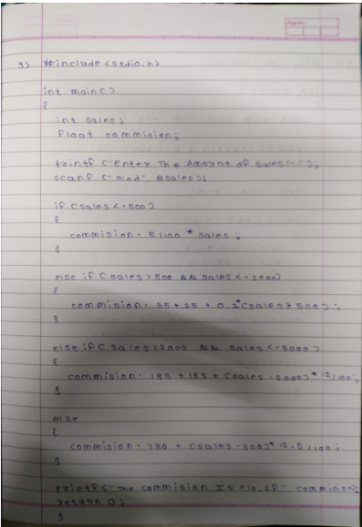

**Output:-**

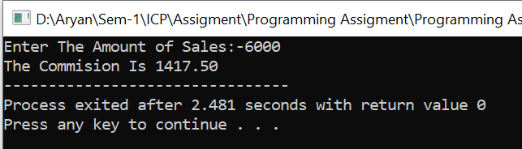

**Experiment: 10**

**Aim:-**  Write a program to count the digits of a number

**Software:-** Dev C++

**Code:-**

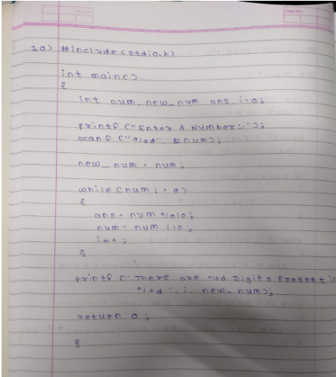

**Output:-**

